

Capstone Project Phase A – 61998

Project code:24-1-D-18

Realtorsphere - Software for real estate agents

Marina Shteinfer - 323305458

[Marina.Shteinfer@e.braude.ac.il](mailto:Marina.Shteinfer@e.braude.ac.il)

Hanna Kruchenetzky - 207409764

[hanna.kruchenetzky@e.braude.ac.il](mailto:hanna.kruchenetzky@e.braude.ac.il)

Advisor:

Zeev Barzily

[zbarzily@braude.ac.il](mailto:zbarzily@braude.ac.il)

1. **Abstract:**

The challenges that real estate agents face are the traditional methods in the industry which are often inefficient, involving excessive paperwork, disparate data sources, and time-consuming processes that need to be modernized.

For this purpose, a new software solution called "Realtorsphere" is planned.

This software aims to provide a comprehensive toolset to streamline workflows, enhance customer engagement, and elevate the effectiveness of real estate professionals. It will incorporate features like customer relationship management (CRM), property matching algorithms, documentation tools and multi-device accessibility.

The development approach includes researching existing solutions, interviewing real estate agents to understand their needs, exploring relevant technologies like PropTech and algorithms, and carefully selecting tools and frameworks. Most Important technologies being considered include PyCharm/Visual Studio for development, GitHub for version control, MySQL/MongoDB for Data Base, HTML and Javascript for the web interface, Python for the backend, APIs, and cloud services.

1. **Introduction:**   
   **The problem we want to solve:**  
   The traditional methods employed in the real estate industry are often marked by exhausting paperwork, disparate data sources, and time-consuming processes that need to be updated in the face of the evolving technological landscape. Real estate businesses suffer heavily from mistakes that can be avoided through effective customer engagement and [data management systems](https://www.softwaresuggest.com/data-management-software).  
   The demands of the real estate market are ever-growing, so the crucial role of the agents in this field in facilitating property transactions demands a streamlined and technologically adept approach. Recognizing the urgent need for progressive solutions, this software program aims to cope with the pressing challenges faced by real estate agents, providing them with an effective toolset to enhance their workflow, improve interactions with clients, and in the long run- elevate their effectiveness in a highly competitive industry.  
   This software aims to bridge the gap between outdated practices and modern technological capabilities and provide a comprehensive solution to the specific needs of real estate professionals.
2. **Background and Related work:**

To better understand the real estate field and the kind of software realtors work today, we decided to investigate what programs exist today and what they offer.   
Solutions that exist today:

HubSpot is a comprehensive customer relationship management (CRM) platform that offers a suite of marketing, sales, customer service, and content management tools. It allows businesses to manage their interactions with customers, automate various processes, track leads, analyze data, and create personalized marketing campaigns.

Monday.com is a versatile work operating system (Work OS) that offers various features and templates for managing projects, tasks, and workflows across different teams and departments within an organization.

Its features include customizable boards, timelines, automation, integrations, and collaboration tools that can be tailored to fit sales processes and CRM needs. Users can create visual pipelines to track leads, deals, and customer interactions, set up automated workflows for repetitive tasks, integrate with other software tools like email clients and communication platforms, and collaborate with team members in real time.

Pipedrive is a customer relationship management (CRM) software designed to help businesses manage their sales pipelines effectively. It provides a user-friendly interface and customizable features to streamline the sales process and track deals from initial contact to closure. With this program, users can create visual pipelines to track deals and sales opportunities at different stages of the sales process. It also allows users to store and organize contact information for leads, prospects, and customers in a centralized database. In addition, users can schedule tasks, set reminders, and log activities related to sales interactions to ensure timely follow-ups and engagement with leads. Other qualities are Email Integration with Gmail and Outlook, reporting, and Analytics tools to track sales performance and customize pipelines, fields, and workflows to align with their specific sales processes and requirements.

Salesforce is a cloud-based CRM platform that assists businesses in managing sales, marketing, and customer service activities by providing tools for storing and organizing customer information. It offers automation features to streamline sales processes and track sales opportunities through various pipeline stages. Salesforce also includes marketing automation tools, customer service support features, analytics, reporting capabilities, and customization options for integrating with third-party applications.

Capsule is a cloud-based CRM software tailored for small and medium-sized businesses (SMBs) to manage contacts, sales pipelines, and customer interactions efficiently. Its key features encompass contact management, customizable sales pipelines, email integration, task and calendar management, reporting and analytics, and customization options to align with specific business needs. Capsule offers a user-friendly interface and essential functionalities to streamline sales processes and enhance customer relationships.  
  
In Israel, the current solutions are Homely, nadlanOne, and Bmby.

BMBY is a real estate agent system that streamlines various tasks such as managing client portfolios, matching properties to customer requirements, facilitating communication via SMS and email, generating and organizing reports on sales and market trends, marketing properties on websites and real estate boards, integrating with MLS systems, and providing google map views of properties.

Homely offers professional services and products tailored to real estate agencies, primarily focusing on their website as a platform to promote agency publications. It includes internet brokerage software utilizing Microsoft Silverlight for remote work, local brokerage software by Midan Software for customizable interfaces and automatic backups, and a mobile application for managing office tasks and accessing real estate information worldwide.

NadlanOne is a real estate program with a user-friendly interface and a mobile agent for property notifications. It has a comprehensive database of apartments and mediators' publications, integrates with MLS in the country, and offers features like digital signature and Comparative Market Analysis reports. Additionally, it enables the creation of unlimited landing pages for property marketing and operates seamlessly with property IDs, ensuring continuous support for agents 24/7.

We surveyed these softwares, to better understand this field these days. We asked realtors the next questions:   
* What software do you use today?  
* Why did you choose this software?   
* How would you better it, or which features would you add to it?   
* What are the basic features every real estate software should have?   
*Would you like the software to have a field for your sales goals and a counter that you could advance every time you make a sale?  
* Anything else you’d like to add?   
Based on the answers we’ve collected we came to these conclusions about the Israeli real estate softwares:

* Some CRMs can be better. It should be easier to edit client’s details and add notes about clients.
* There is a need for documentation of meetings.
* Most softwares is available on multiple devices and it increases productivity.
* The software needs to be easy to understand and use, to have an archive of properties, to collect properties from the web and to be synchronized with Whatsapp.

Thanks to this information we decided to investigate more about the technologies in the real estate sphere and algorithms that might be useful during the development process.

Literature Review:

While doing the research we encountered the term **‘proptech’** multiple times.

PropTech (property technology) refers to using information technology (IT) to help individuals and companies in the real estate industry, similar to how FinTech focuses on technology in finance.

PropTech aims to streamline and connect processes for various real estate market participants like buyers, sellers, brokers, lenders, and landlords.

Major Market Segments in PropTech:

Smart Home: Digital platforms that monitor, manage, or operate specific property assets in smart homes.

Sharing Real Estate: Technology that facilitates the processes involved with sharing or renting real estate assets.

Real Estate FinTech: Applications that involve selling and buying real estate assets.

The driving forces of PropTech are a convergence of technologies, cloud computing, and digital transformation.

The goals of PropTech include minimizing costs, maximizing efficiency, saving time, and personalizing property management.

In addition, Blockchain technology is expected to play a role in creating a secure infrastructure for real estate transactions and operations.

PropTech is a relatively new field, but it is rapidly evolving and gaining traction in the real estate industry. The adoption of PropTech solutions is expected to continue increasing as the industry embraces digital transformation.

In summary, PropTech represents the integration of information technology into the real estate industry, to streamline processes, enhance efficiency, and provide innovative solutions for various real estate stakeholders.

The article “The Future of Real Estate is Shifting to Proptech” explains that the real estate industry, traditionally resistant to change, is now undergoing a significant digital transformation driven by the emergence of Proptech.

Factors like the pandemic, evolving consumer behaviors, and advancements in adjacent technologies have accelerated the adoption of proptech. There is a clear divide between more experienced real estate professionals and the younger generation of leaders when it comes to the perceived value and adoption of proptech.

The younger generation, having grown up with technology, is more inclined to embrace proptech as a competitive advantage.

Proptech solutions offer significant advantages in terms of information, collaboration, and productivity, making those who adopt them more efficient and strategic.

Key areas of impact include automating lease management, reducing the risk of human error, and elevating human personnel to focus on strategic decision-making. The influx of venture capital into the proptech space and the shift in mindset among the younger generation of real estate professionals are driving the widespread adoption of proptech.

Proptech is rewriting the future of commercial real estate by re-engineering processes and enabling teams to work smarter and more efficiently.

Real estate, though traditionally slow to change, is undergoing a tectonic shift with the rise of proptech.

Those who understand and embrace this shift by adopting proptech tools and practices will be better positioned to succeed in the evolving real estate landscape.

In summary, the article highlights how the real estate industry is being transformed by the emergence of proptech, driven by a generational divide and the advantages offered by these digital tools, ultimately shaping the future of the industry.

Another article "Technology Is Revolutionizing The Real Estate Industry" talks about how the real estate industry is undergoing a significant digital transformation, driven by the adoption of various technologies.

The article highlights several key technologies that are reshaping the real estate industry, including:

- Artificial Intelligence (AI) and Machine Learning

- Big Data and Analytics

- Internet of Things (IoT)

- Augmented Reality (AR) and Virtual Reality (VR)

- Blockchain

- Crowdfunding and Peer-to-Peer Platforms

These technologies are being integrated into various real estate processes, such as:

- Property search and selection

- Valuation and pricing

- Transactions and payments

- Property management

- Facility management

The adoption of these technologies is leading to increased efficiency, transparency, and enhanced user experiences for both real estate professionals and consumers.

The paper also discusses the challenges and considerations associated with the integration of technology in the real estate industry, such as data privacy, security, and the need for digital literacy.

The paper suggests that the real estate industry will continue to evolve and become more technology-driven, with further advancements and integration of emerging technologies.

In summary, the research paper highlights the significant impact of various technologies on the real estate industry, transforming the way properties are searched, valued, transacted, and managed, while also presenting both opportunities and challenges for the industry.

In addition, the research paper titled "Key Determinants of Real Estate Service Quality Among Renters and Buyers" explores the comparison of quality perceptions between virtual servicescapes and some of the points that were mentioned in the paper are:

Virtual Servicescapes vs. Physical Service Encounters:

The study found differences in how renters and buyers perceive service quality in the pre-purchase, service encounter, and post-encounter stages.

Factors like property descriptions, visuals, realtor behavior, and post-encounter relationships were important.

Importance of Tangibility in Service Quality:

The paper emphasizes the role of tangible factors like aesthetics, ambiance, design, and physical appearance in influencing customer experiences in real estate.

Virtual Servicescape Quality:

High-quality visuals and pictures on real estate websites are crucial for both buyers and renters in their decision-making process.

Search tools and mapping functions also play a significant role in enhancing the user experience.

Physical Service Encounter Factors:

Factors like responsiveness, access, communication, and reliability during the in-person service encounter are key determinants of customer satisfaction.

Technology Integration:

Real estate firms need to focus on training agents and improving website design to meet evolving customer expectations.

Technology, especially virtual servicescapes, is becoming more important than physical environments for consumers.

Implications for Real Estate Firms:

The findings recommend that real estate companies should invest in both agent training and website design/content to enhance service quality and customer satisfaction.

In summary, the paper highlights the importance of integrating technology, particularly virtual servicescapes, to improve service quality perceptions and meet the changing expectations of real estate buyers and renters.

Our software will use a recommendation algorithm. Some research that we’ve done about it led us to an article: “What is content-based filtering? Benefits and examples in 2024”  
In summary, this article says that a recommender system called content-based filtering makes recommendations based on user preferences and item qualities, such as those seen in online marketplaces. By using data from searches and purchases to build a user profile, it may match things to specific users and provide personalized suggestions. Examples include movie recommendations on Netflix and book suggestions on Amazon. The advantages of these systems are that they are transparent and independent of other user data, but there are drawbacks as well, such as their limited diversity and scalability. Proficiency in Python programming, and machine learning, and familiarity with specialist libraries and big data tools are among the skills required to develop such systems.

Another article that talked about it was “A Survey of Collaborative Filtering Techniques”  
It said that one popular method for creating recommender systems is collaborative filtering or CF. It makes predictions or suggestions about unknown preferences for other users based on the known preferences of a group of users. Three primary types of CF strategies are covered in this paper: memory-based, model-based, and hybrid CF algorithms. It addresses the main issues that CF systems face, including data sparsity, scalability, and privacy protection and it lists the different methods that have been suggested to deal with these issues. An explanation of the Netflix prize challenge, a well-known contest that drew researchers to create sophisticated CF algorithms, is also included in the paper.

“Collaborative Filtering in Recommender Systems: An Overview” Is an article that we found that also provides us with an example of a code for this algorithm. It explains that by examining information from similar users or goods, collaborative filtering is a personalized recommender system technique that forecasts user preferences. It uses user-to-user comparison and similarity measurements to make recommendations for products based on previous user interactions. The article adds that collaborative filtering increases user engagement and sales through personalized suggestions by forecasting how users will evaluate unseen products.   
  
For our project, we decided to combine these two approaches. The system will be able to provide an in-depth recommendation system that will consider both the inherited qualities of properties and the past preferences of clients by merging these two methods. The drawbacks of each separate technique will be addressed by this hybrid approach, which also offers more precise and tailored advice.   
The hybrid approach can also make use of machine learning techniques to improve suggestion accuracy and adaptability. In the real estate industry, a hybrid strategy that combines collaborative filtering, content-based filtering, and machine learning approaches would probably be the most successful way to suggest homes to customers.

1. **Our suggested solution:**

RealtorSphere is a comprehensive software solution made for real estate agents designed to improve property management, customer interactions, and overall efficiency in the dynamic real estate landscape.  
Characteristics of the property management side of the software will be:   
Properties will be identified by a unique number and additional details such as price, size, mode(active, archive, closed), location, property plan, number of floors, and parking options (is there private parking? Can you buy more than one parking spot? What is the public parking situation in the area?), air conditioning, bars, balcony or garden, safe room and storage room, is the property a smart home, information about public transportation in the area, nearby facilities, accessibility features and security measures (intercom or guard).  
Realtors view properties seamlessly through Google Street and upload photos, videos, and structural plans.   
The property types in the software are apartments which are categorized as ordinary, duplex, or penthouses, with additional details about the floor number the apartment is on and the existence of elevators, and private houses that are characterized by the existence of an attic and basement, as well as the layout of the building.

The software will help with client management. Property owners are identified by first name, last name, email, phone number, and address, and clients are identified through their contact details (name, surname, email, and phone) the system will intelligently match properties with client preferences, notifying realtors of potential matches.

Realtors are identified by first and last name, email address, password, phone number, and real estate license number. The realtor can manage and organize assets by city, type, potential customers, and status. Additionally, the realtor can view listings from external websites and easily update property details.   
The realtor will be able to record client details, connect them with relevant properties, schedule appointments, manage a work diary, set sales goals, track progress, receive reminders for daily tasks, and update and mark as ‘completed’ tasks in the work diary.  
 Price negotiation and communication can be done through the software. The realtor can update and save price proposals from owners and customers and send emails with price updates through the software for negotiation. In addition, the realtor can contact an appraiser to help set the initial price for the property through the program.   
The software will include an archive for properties moved there by the real estate agent after they’ve been sold or if the owner decides not to sell/rent, with the option to add a reason.   
The software will generate detailed reports on sales data, including popular sales areas, and price ranges. The realtors will be able to filter the reports and easily choose those that they want to see.   
Also, the realtor can organize client documents into folders for easy access.

**Who are the stakeholders & how will the software benefit them?**

The software will be beneficial, of course, for real estate agents. RealtorShpere purpose is to improve property management: it will streamline property management tasks, allowing realtors to organize, update, and track asset details easily. Other goals are to improve client matching by identifying properties that align with client preferences, increase customer satisfaction, and make the process of the transaction easier.

The software will also help with task management- it will aid in scheduling appointments, managing work diaries, and setting sales goals, to increase productivity.

Stakeholders can also be property owners. The software will be beneficial for them because it streamlines communication. The software can ease the communication between real estate agents, property owners, and buyers during negotiations, ensuring a smoother selling or renting process.

Property buyers can also benefit from this software. It gives property recommendations. Buyers receive personalized asset suggestions based on their preferences, enhancing their experience and satisfaction. It also provides convenient communication with the realtor and the seller, ensuring quick responses to inquiries and updates on properties.

Detailed reports and analytics provided by the software will be useful to realtors and property owners for data-driven decision-making. Real estate agents will be able to make informed decisions for the growth and optimization of their businesses.

1. **Development Process:**

In the developing process of this software, we first investigated the world of real estate and what real estate programs look like. We searched for existing programs of realtors that are available on the market and also reached out to realtors so that they could explain to us how they work, what they liked about their program, and what they would like to improve. Next, we researched how technology, and the real estate field are related to know which technologies are better to use in our project. In addition, we also looked for useful algorithms that may be beneficial to the project. We concluded that a good matching algorithm may help realtors close “deals” more effectively and efficiently. Next, we planned our software, how it would look like, and what the realtor would be able to do with it. In the next stage, we plan to choose the technologies we will use, the work methodology, and the testing plan.

1. **Tools and methods we’re considering for the development:**

Integrated development environment: pyCharm, Visual Studio

-JetBrains’ **Pycharm** is a robust integrated development environment (IDE) made especially for Python development. Its main goals are to improve developer productivity and simplify Python coding processes. Its integrated code aid, which includes functions like code completion, code analysis, and error highlighting to help developers produce cleaner, more effective Python code, is one of its most notable features. With support of breakpoints, watches, and variable inspection, Pycharm also provides debugging features that make it simple for developers to analyze and debug Python projects. Moreover, Pycharm easily interfaces with well-known Python testing frameworks, such as unittest and pytest, allowing programmers to create and execute unit tests right inside the integrated development environment.   
In addition, Pycharm is a web development tool that offers great support for well-known Python web frameworks, like Django and Flask. It has built-in server integration, code navigation, and project templates. Additionally, PyCCharm has integrated support for Git, Mercurial, and Subversion version control systems, enabling developers to manage their code repositories right within the IDE (We will be using Git).  
 PyCharms’ specialized support for Python programming and an abundance of features that are intended to improve productivity and optimize coding workflows make it a good choice for our project. PyCharm’s intelligent code assistance may greatly enhance the readability and quality of Python code by flagging mistakes in real-time, completing code analysis, and offering useful suggestions. This results in Python code that is clearer and more efficient. Furthermore, PyCharm’s sophisticated debugging features will facilitate faster bug fixes and more seamless development cycles by simplifying the troubleshooting and resolution of problems in our Python application. Moreover, Pycharm’s smooth interaction with well-known Python testing frameworks makes it simple to conduct unit tests right inside the IDE, guaranteeing the dependability and stability of the codebase of our project.

-Microsoft’s **Visual Studio** is a feature-rich integrated development environment (IDE) that was first designed for .NET development but now supports Python and a variety of other programming languages and technologies. It is appropriate for projects requiring a variety of technologies since it offers comprehensive tooling and functionality for Python development. Visual Studio is a flexible option for developers working on a range of projects because it provides strong support for several programming languages, including Python, C#, JavaScript, and more. Developers may create code more quickly with the use of its intelligent code assistance features, which include code navigation, syntax highlighting, and code completion.   
 Furthermore, Visual Studio easily connects with Microsoft Azure cloud services, allowing programmers to launch, administer, and track cloud-based apps right from the integrated development environment. That means that regardless of their geographical location, several developers can collaborate in real-time on the same codebase using collaborative development capabilities live Live Share, which improves team productivity and cooperation.   
 Because of Visual Studio’s extensive tools and support for a variety of programming languages and technologies, including Python, using it for our project would be advantageous. Because of its strong support for Python and other languages like C# and JavaScript, it may be used for a variety of requirements in projects. We might create code more quickly and with accuracy with Visual Studio’s code aid tools, which include code navigation, Syntax highlighting, and code completion. With tools like breakpoints and step-by-step debugging to help with troubleshooting and problem-solving, the IDE’s debugger makes it simple to debug Python code.

* **Android Studio** is an integrated development environment (IDE) for android applications development. With this tool developers can build an application for the android platform. Android studio allows developers to write, test code and deploy. This can be helpful to upload the software to be available to android users.

Version Control: Github, for collaboration and code management-  
 A popular tool for version control and teamwork is **Github**. It makes it possible for numerous developers to collaborate on the same codebase at the same time, monitor changes, and efficiently oversee project workflow.   
 There are several advantages to using GitHub for our project, and they can significantly improve team cooperation and the development process. GitHub acts as a centralized version control system that will enable us to keep track of codebase alterations, roll back to earlier iterations when necessary, and track all project changes over time. This provides a common repository where all team members may access and contribute to the codebase, ensuring code integrity and facilitating smooth team collaboration.   
 We will be able to work on separate features simultaneously without interfering with each other’s code thanks to GitHub’s branching and merging capabilities. It is simple to establish branches for new features or bug fixes, and if they are finished and approved, to merge the changes back into the main codebase.

Data Management: MySQL, MongoDB  
 -**MySQL** is a popular open-source relational database management system (RDBMS) that is ideal for a variety of projects, including web applications, e-commerce platforms, and data-driven applications. It is known for its dependability, scalability, and robust performance. Concerning relational data, it provides an extensive feature set that encompasses support for complex queries, transactions, and data integrity requirements like unique and foreign key constraints. Because MySQL compiles with ACID (atomicity, consistency, isolation, durability) standards, it can be used in mission-critical applications that demand high degrees of consistency and dependability. Furthermore, MySQL offers top-notch support for indexing and optimizing strategies, enabling programmers to maximize database speed and concurrency.   
 MySQL will be beneficial for our project because structured data like property listings, client details, and transaction records frequently used in real estate applications may be stored in MySQL thanks to its powerful relational database management features. Its ability to handle complex queries and transactions guarantee effective data retrieval and management, making jobs like managing client relations, securely processing financial transactions, and finding properties based on a variety of criteria easier.

-A well-liked open-source NoSQL database, **MongoDB** is great for projects needing agile and scalable data storage options because of its performance, flexibility, and scalability. Developers may easily store and search complex data structures using MongoDB thanks to its flexible document-oriented data format, which is based on documents that resemble JSON, in contrast to standard relational databases like MySQL. Because of the flexibility and agility offered by its schema-less design, developers can swiftly iterate and adjust to changing data requirements without having to worry about complicated schema migrations. Because of its distributed architecture and inherited horizontal scalability features, MongoDB is highly scalable, enabling developers to easily expand their databases to accommodate increasing workloads and data volumes.  
 MondoDB’s scalability and versatility make it a good solution for our real estate project. Complex data structures are frequently found in real estate applications, such as property listings, client information, and transaction records, and may be stored in a manner that is adaptable and simple to access thanks to MongoDB’s document-oriented data model. We will be able to effectively manage a variety of data kinds and relationships within the real estate field thanks to this document-based approach, which makes data retrieval and storage simpler.   
 Furthermore, MongoDB’s schema-less architecture eliminates the requirement for predefined schemas, which may make it easier for us to iterate on our applications and adjust to changing data requirements without being constrained by inflexible data models.  
  
Frontend framework: HTML, JavaScript and React for web application.

* **HTML** is a programming language that is most commonly used across platforms and browsers to create web pages and user interfaces. Users will be able to access our real-estate application from a variety of devices, such as desktop computers, laptops, tablets, and smartphones, thanks to broad compatibility and accessibility.  
   HTML is lightweight and simple. Because of its simple syntax and structure, we may quickly prototype and develop our application and make revisions to its user interface.
* **JavaScript** is a high-level programming language and the main technology of web application. It is used often for client-side web page behavior but also can be used for backend. JavaScript is used for many non-browser environments like NodeJS as well.
* **React** is an open-source front end JavaScript library. It is used mainly to build user interfaces based on parts of the page like buttons, lists, navigation, etc. React allows you to design each component individually so it is easier to understand the purpose of each part. Thanks to that it is used to develop web pages and mobile applications.

Backend:

* **Python** is a high-level programming language. Its design makes code simpler to write and easier to read which make it a very popular choice for development language. Python supports multiple programming paradigms, including structured, object-oriented and functional programming. It also has a comprehensive standard library and additional libraries. Python can be used for web application development on server side, software development, mathematics and more. We want to use python on the server side mainly because it has simple syntax, can be used on many platforms and handle big data and perform complex mathematics.
* **Nodejs** is a cross platform and open-source JavaScript environment. It is used for server-side programming so developers can use JavaScript there as well. Nodejs is a single threaded, non-blocking and asynchronous programming which is very effective working with memory. Thanks to Nodejs we can have dynamic page content, to open, modify and close files on the server side, to collect data from form and update DB.
* **API** - Application Programming Interface is a code that helps two different programs to communicate. API connects different programs together as a 3-party program. It helps to hide the “service” program from the requesting program, only sending it the parts that will be useful. API used in social media, streaming services, sites like booking that collect data about hotels and flights, and etc. In our project it can be useful to collect data about properties of sale.

Client Server Model:

* **Client server** is a model of communication between two programs, the client program which asks a service from a server program. There can be several clients to a single server. The connection between client and server is like this: client sends request for data to the server through the network and the server accepts the request, finds the data, processes it and sends it back to the client. Client server uses protocols such as DNS, http, https which are common for web communication. The main advantages of this model are less maintenance and the client, and the server can be changed separately.

Work Methodology:

**Agile methodology** is a project management method approach that breaks the project into small phases, after each phase is complete the project gets feedback and before the next phase is started the developers make changes and plan the next phase accordingly. This method highlights the collaboration between developers and improvement. It works there is a cycle of planning, executing and evaluating. The heart of the agile methodology is the collaboration between different teams of the development project and the trust between them. Agile uses feedback mechanisms and constant improvement. The project gets feedback when each part is complete, and thanks to that if there are changes to make it will be easier because the rest of the project is not done yet, so there is no need to redone parts and next phases can be altered so it will suit the new plan and be less fixed.

1. **Product**:

To develop “Realtorsphere” we collected and summarized the requirements for this application. We also designed diagrams that can explain how the realtor will be able to use this program, what entities it will consist of (how the DB will look like) and show the process of one the main activities in the application. In addition, we also designed a paper prototype of some of the main screens of our application.

Requirements:

Functional Requirements:

1. The system will allow realtors to add, update and delete property listings, providing details such as size, price, location, facilities and additional features.
2. The system allows realtors to classify properties by type like apartments, houses etc.
3. The system will allow realtors to upload videos, photos and relevant files to the system.
4. The system will allow realtors to change property status: archived, sold or active.
5. The system will allow realtors to save clients and owners information and manage it.
6. The system will allow realtors to match buyers with properties based on the buyer requests.
7. The system will allow realtors to manage calendars and set meetings.
8. The system will allow realtors to set and track goals.
9. The system will allow realtors to update and track price suggestions for negotiation.
10. The system will allow realtors to send emails.
11. The system will create reports about sales data, popular areas, price ranges, properties activities and client activities.
12. The system will allow realtors to filter reports searches.
13. The system will allow realtors to organize clients and owners documents.

Non- Functional requirements:

1. The system will feature a user-friendly interface for easy navigation and task management. (Usability)
2. Responsive design for optimal viewing on different devices (Compatibility)
3. Intuitive design will facilitate quick learning and adoption by real estate agents (Usability)
4. Secure authentication and authorization mechanisms (Security)
5. Integration capabilities with external systems and APIs will facilitate seamless data exchange (Integration)
6. Modular and extensible code structure (Maintainability)
7. A well-documented codebase will ensure ease of maintenance and future updates (Maintainability)
8. Adherence to relevant industry regulations and data privacy laws (Compliance)

Diagrams:

Architecture diagram:

In this diagram we can see 3 main parts:

1. Frontend - that will hold the design of our software and will communicate with the user. We want it to be accessible in several platforms, we will use html and JS.
2. Backend - it will be the layer between the frontend and DB and do all the functionality of the software.
3. DB- store all the data necessary to the realtors.

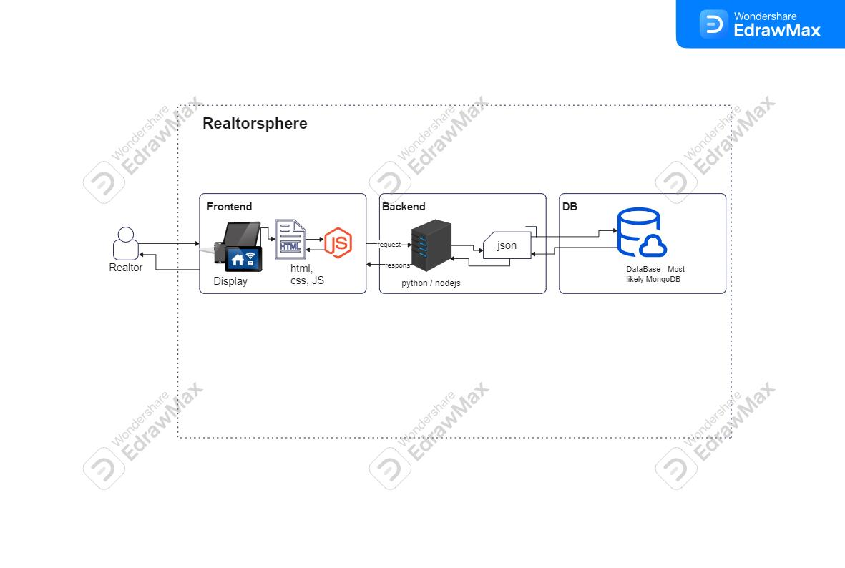

Use case diagram:

In this software there is only one user, the realtor. As a result of this diagram there is only one actor.

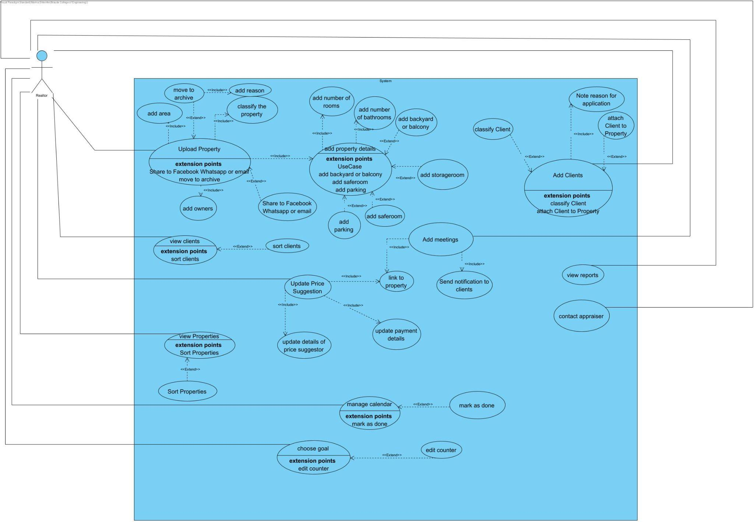

Class diagram:

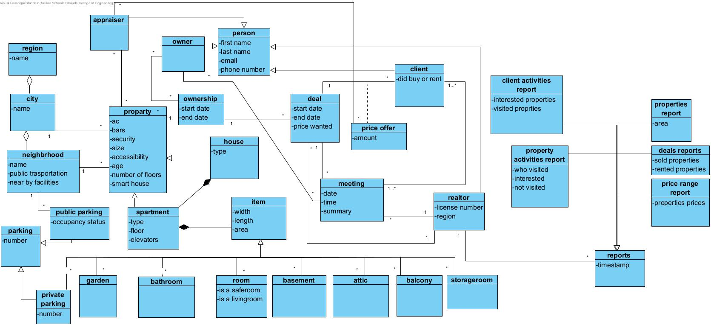

Activity diagram:

The activity described in this diagram is “adding potential clients/buyers and suggesting property to them”. When adding new clients, the realtor adds to the system their preferences, and the software will try to match properties based on that. After a few suitable matches the realtor will send the list to the client to choose from.

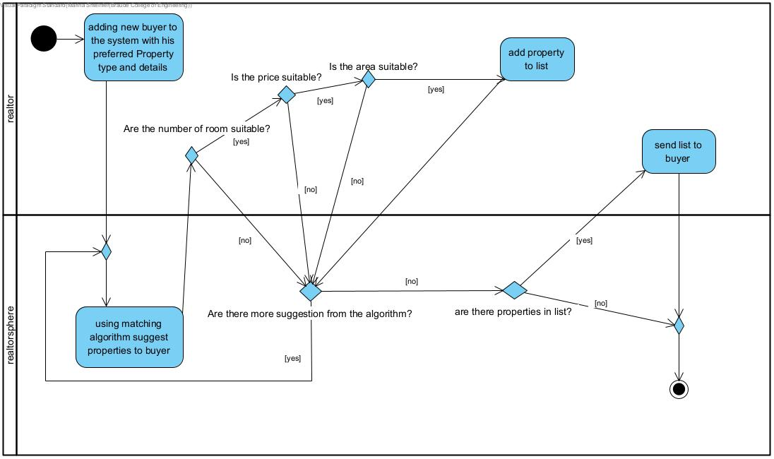

1. **Challenges:**

During the planning of the project, we encountered several challenges. The first was the war that started this year, which caused great concern and uncertainty regarding the continuation of studies in particular.

In addition, the subject of mediation was completely unfamiliar to us, so we had to learn it from the beginning. Another problem was the difficulty in finding mediators who would answer the questions we had, so we had to make do with a small number of people who cooperated with us. Additional issues we anticipate will be integrating data from multiple sources which can be complex and require strong data management strategies. Also ensuring the software can handle large amounts of data and user traffic without compromising performance.

1. **Evaluation/Verification Plan:**

For this project we have planned a test plan. This test plan is to ensure that the application will run smoothly, and all the components will work properly. Some of the testing will be done manually, and some with unit testing.

Unit Tests:

**Login and Registration:**

|  |  |  |  |  |
| --- | --- | --- | --- | --- |
| Comments | Precondition | Expected Result | Description | TestID |
|  | User is defined in DB | User is logged in and navigated to the home page. DB is changed the status as “Logged in” | Login with valid credentials | LoginSuccess |
| Error, username or password are not correct | User isn’t defined in DB, or one for the Login credentials isn’t correct | Error: The user didn’t log in to the system. | Login with invalid credentials | LoginFail |
| The User registered successfully | User isn’t defined in DB. | User registered successfully | Register a new user with valid details | RegisterSuccess |
| Error, invalid credentials | Details aren’t correct. | Error, User failed to register | Register a new user with invalid details | RegisterFail |
| Error, User is already in the system | User already defined in DB | Error, User failed to register due to user already exists | The user is already registered in the system. | RegisterFail |

**Properties clients and owner tests:**

|  |  |  |  |  |
| --- | --- | --- | --- | --- |
| TestID | Description | Expected Result | Precondition | Comments |
| AttachClientToPropertySuccess | Realtor added a valid client to the property. | Client attached to the property successfully. | Client is defined in DB | Client added successfully to property. |
| AttachClientToPropertyFail | Realtor added a invalid client to the property. | client isn’t attached to the property because user does not exist | Client isn’t defined in DB | Attachment failed |
| AttachOwnerToPropertySuccess | Realtor added a valid owner to the property. | Owner attached to the property successfully. | Owner is defined in DB | Owner added successfully to the property. |
| AttachOwnerToPropertyFail | Realtor added a invalid owner to the property. | Owner isn’t attached to the property because user does not exist | Owner isn’t defined in DB | Attachment failed |
| AddPropertySuccess | Adding new property with valid details. | New property added successfully | Property isn’t defined in DB  or not in active mode | Property added successfully |
| AddPropertyFail | Adding property that already exists in the system. | New property added failed | Property is already defined in DB and in active mode | Error, property is already existing and active |
| AddPropertyFail | Adding new property with invalid details. | New property added failed | Property isn’t defined in DB. | Error, invalid credentials |
| UploadPicsFromCamera | Uploading pictures from the phone camera. | Photos added successfully |  | New pictures were added |
| UploadFiles | Uploading files from the phone, computer or tablet. | Files added successfully |  | New Files were added |
| AddOwnerSuccess | Adding a new owner with valid details. | New Owner added successfully | Owner is not defined in DB | Owner added successfully! |
| AddOwnerFail | Adding an owner that already exists in the system. | Failed adding owner because the owner is already existing | Owner is defined in DB | Error, Owner already exists in the system! |
| AddOwnerFail | Adding a new owner with invalid details. | Failed adding owner because one of the details is not correct | One of the credentials isn’t correct | Error, credentials aren't correct! |
| AddClientSuccess | Adding a new client with valid details. | New Client added successfully | Client is not defined in DB | Client added successfully! |
| AddClientFail | Adding a client that already exists in the system. | Failed adding new client because client is already existing | Client is defined in DB | Error, client already exists in the system! |
| AddClientFail | Adding a new client with invalid details. | Failed adding new client because one of the details is not correct | One of the credentials isn’t correct | Error, credentials aren't correct! |
| MatchingAlgorithmSuccess | The algorithm searches and finds a property to clients according to their profaners. | Algorithm finds new match | There are properties existing in DB with clients wishes. | New match is found. |
| MatchingAlgorithmFail | The algorithm searches and doesn't find a property to clients according to their profaners. | Algorithm doesn’t find new match | There are no properties existing in DB with clients wishes. | No matches are found. |
| MovePropertyToArchive | Move property to archive. | Property is in the archive. | Property in defined in DB |  |
| AddMeetingSuccess | Try adding new meetings with clients or owners. | Meeting added successfully and save in DB | Client/Owner is defined in DB | Meeting have been added successfully |
| AddMeetingFail | Try adding new meetings with clients or owners. | Adding Meeting is failed, and meeting is not saved to DB | Client/Owner is defined in DB | Connection error! |
| AddPriceSuggestion | Updating deal offer with new price suggestion. | Suggestion added successfully and save in DB |  | Price offer updated! |

**Report:**

|  |  |  |  |  |
| --- | --- | --- | --- | --- |
| TestID | Description | Expected Result | Precondition | Comments |
| OpenReportSuccess | Open existing report | Open report | The end of the month |  |
| OpenReportFailReportIsNotPreducted | Searching non existing report | There is not new report, blank page is opened | Not the end of the month | Blank page |

Manual Tests:

|  |  |  |  |  |
| --- | --- | --- | --- | --- |
| TestID | Description | Expected Result | Precondition | Comments |
| Navigation from the login screen to the home screen after login | Open the application, enter valid login credentials, and click on the 'login' button | The application navigates to the main screen | User put correct details and exits in DB |  |
| Navigation between screens | In the application choose from the navigation bar, wanted page and click on it. | The application navigates to the wanted screen | User logged in |  |
| SendEmailSuccess | In the Client/Owner screen press the “Send Email” button. New window is opened in the Email server. Write new mail and click send. | Mail has been sent successfully | Client/Owner is defined in DB | Mail has been sent successfully! |
| SendEmailFail | In the Client/Owner screen press the “Send Email” button. New window is opened in the Email server with the receiver email already written. Write new mail and click send. | Mail sending is failed | Client/Owner is defined in DB | Connection error! |
| SharePropertySuccess | In the property's screen, click the “share in media '' button. Choose the platform: “Facebook”, press “Share”. | Sharing property successided | Property in defined in DB | Property shared successfully! |
| SharePropertyFail | In the property's screen, click the “share in media '' button. Choose the platform: “Facebook”, press “Share”. | Sharing property failed | Property in defined in DB | Connection error! |

1. **Expected Achievements:**

Project objective:

In this project we have set goals to achieve. The achievements of this project will focus on the usefulness of this software.

The final goals of our project are:

1. Develop a software for real estate agents.
2. Design a user-friendly program that will be easy to use without any special teaching.
3. Help realtors to reach out to more properties and clients.
4. Help realtors to organize their work, client base and properties, so it will be easier to manage.
5. To make this software available in many platforms and make it more approachable.
6. To make deals close quicker with the matching algorithm that will match buyers and renters to properties.

Success Criteria:

1. The software “Realtorsphere” is developed and uploaded to the public.
2. Realtors that will try the program have positive feedback.
3. The software will match the properties for sale and rent to clients based on their preferences in the most accurate way possible.
4. More realtors and real estate offices will want to use the application.
5. **Reference:**
6. Real estate and CRM software - <https://www.top10.com/crm/real-estate-comparison?utm_source=google&kw=real%20estate%20crm%20software&c=643177497781&t=search&p=&m=e&adpos=&dev=c&devmod=&mobval=0&network=g&campaignid=19423913510&groupid=146476383284&targetid=kwd-1909052482&interest=&physical=1008008&feedid=&a=58951&ts=&topic=&clicktype=&camtype=&gad_source=1&gclid=CjwKCAjwh4-wBhB3EiwAeJsppH62B_qxa6vLTQp-ysbSmvzaaxDj4g7Ai1xEqlcqUKMNrsuuPOiJaxoC0EcQAvD_BwE>
7. NadlanOne - <https://nadlanone.co.il/>
8. Bmby - <https://bmby.co.il/>
9. Homely - <https://webtiv.co.il/welcome/>
10. PropTech (property tech)- <https://www.techtarget.com/whatis/definition/PropTech-property-tech>
11. The Future of Real Estate is Shifting to Proptech - <https://readwrite.com/the-future-of-real-estate-is-shifting-to-proptech/>
12. Technology Is Revolutionising The Real Estate Industry - https://www.techbusinessnews.com.au/blog/technology-revolutionising-the-real-estate-industry/
13. Tuzovic, S. (2009). Key determinants of real estate service quality among renters and buyers. *Journal of Services Marketing*, *23*(7), 496-507.
14. What is content based filtering? Benefits and examples in 2024-  
    <https://www.upwork.com/resources/what-is-content-based-filtering>
15. Su, X., & Khoshgoftaar, T. M. (2009). A survey of collaborative filtering techniques. *Advances in artificial intelligence*, *2009*
16. Collaborative Filtering in Recommender Systems: An Overview  
    <https://medium.com/@evelyn.eve.9512/collaborative-filtering-in-recommender-system-an-overview-38dfa8462b61>
17. Pycharm - <https://www.developer.com/languages/pycharm-review/>
18. Visual studio - <https://www.geeksforgeeks.org/introduction-to-visual-studio/>
19. Github - <https://kinsta.com/knowledgebase/what-is-github/>
20. mySql - <https://www.oracle.com/il-en/mysql/what-is-mysql/>
21. MongoDB - <https://www.techtarget.com/searchdatamanagement/definition/MongoDB>
22. Html - <https://www.freecodecamp.org/news/what-is-html-definition-and-meaning/>
23. Python - <https://www.w3schools.com/python/python_intro.asp>
24. Javascript - <https://developer.mozilla.org/en-US/docs/Web/JavaScript>
25. Nodejs - <https://www.w3schools.com/nodejs/nodejs_intro.asp>
26. React - <https://www.patterns.dev/react/>
27. Client - Server - <https://www.geeksforgeeks.org/client-server-model/>
28. API - <https://en.wikipedia.org/wiki/API>
29. Android Studio - <https://www.geeksforgeeks.org/overview-of-android-studio/>
30. Agile methodology - <https://www.atlassian.com/agile>